Scenario Mutability and Need for Cognition: Appointing Blame

Former Student
Florida International University

Method Study Two

Participants
One hundred and sixty subjects, 90% (n = 144) university students, were recruited to participate in study two. Of these 160 participants, 33% (n = 52) were male and 67% (n = 108) were female. Ages ranged from a minimum of 17 to a maximum of 64 with an average of 22.38 years (SD = 5.14). Our sample population consisted of 76% Hispanic Americans (n = 122), 9% African Americans (n = 15), 9% Caucasians (n = 14), 3% Asian American (n = 5), and 3% Others (n = 4). See Table 6.
Table 6
Demographics – Study Two
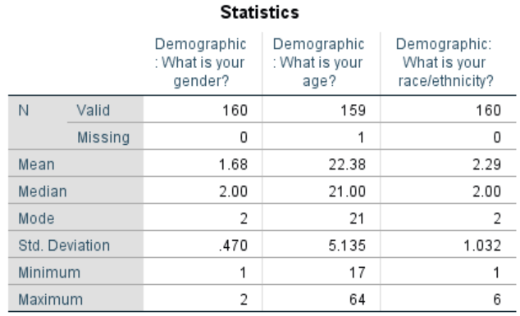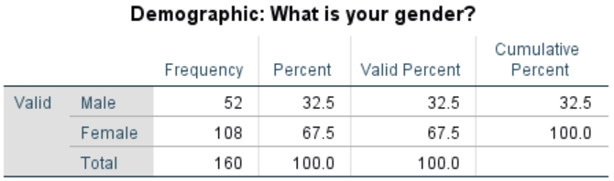
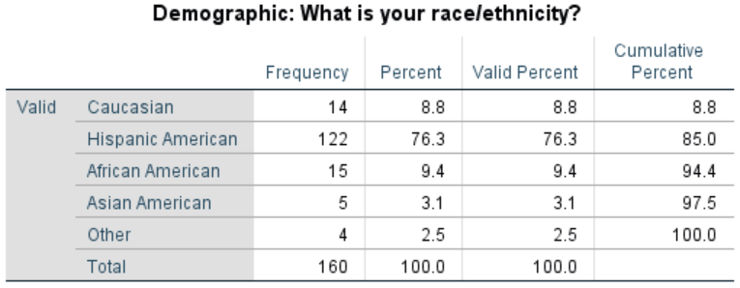
Materials and Procedure
Prospective participants were asked to take part in an online study being conducted for research purposes. If the subject agreed to participate, verbally or otherwise, he or she was directed to the survey developed through Qualtrics software. In accordance with the standardized guidelines for informed consent, subjects were first notified of the potential risks and benefits of participating in the study before being introduced to the research material. Once the participant confirmed their approval, they were eligible to continue with the rest of the survey, which consisted of six different parts or sections.
In section one of the study, we manipulated the subject’s Need for Cognition (NFC) by randomly assigning them to one of two possible groups. Depending on which group the subject was appointed to, they were presented with either five low-NFC or five high-NFC statements procured from the 18-item NFC scale developed by Caccioppo et al. (1984). After reading each statement, the participant was then asked to rate how much they agreed with each remark on a number scale. The numbers on the scale ranged from one (somewhat agree) to seven (completely agree). For example, a participant presented with a set of high-NFC statements was asked to rate the statement “I prefer complex to simple problems,” while a participant presented with a set of low-NFC statements was asked to rate the statement “I only think as hard as I have to” on the previously mentioned number scale.
In section two of the study, participants read one of two short scenarios concerning a paraplegic couple, Tina and Eugene, who requested a taxi for a night out with friends. These scenarios were identical to the ones used in study one. Here, however, we omitted the neutral condition since it did not differ from the unchangeable condition. Once again, and similar to study one, participants continued on to section three of the study, which asked them to provide as many ‘If Only’ statements as possible, meaning that they had to list all the factors they could think of that could have possibly changed the outcome of the event. Subjects were able to complete a total of ten statements, though they were not required to fill in all ten.
Similar to study one, section four presented participants with a series of 12 questions about their general thoughts regarding the specific situation they read about. These questions included how avoidable they thought the accident was, the causal role of the taxi driver in the couple’s death, their thoughts on how much control the taxi driver had, the negligence of the taxi driver, their dissatisfaction of scenario outcome, the foreseeability of the couple’s death, how much blame the taxi driver deserved for the event, how much control Eugene and Tina had in the event, how legally responsible the taxi driver was, how guilty the taxi driver should feel, how fair the taxi driver’s decision was, and how difficult it was to imagine a different outcome. After reading each question, the participant was asked to record his or her response in a scale of one to nine. The last question of section four was a yes or no question that asked the participant whether the taxi driver agreed to drive the couple or not. This final question served as an attention check, which informed us if the participant was actually attentive to the study and allowed us to exclude potentially misrepresentative responses from our data.
Section five of the survey consisted of the remaining eight manipulation check questions for NFC. Similar to section one of the study, the participant was asked to rate eight dispositional statements on a scale of one to seven. For example, the statement “Thinking is not my idea of fun” would be rated from a scale of one (extremely uncharacteristic) to seven (extremely characteristic).
The last section of the study asked for the participant’s demographic information, including gender, age, ethnicity, country of birth, their first language, whether they are a student at Florida International University, etc. Several questions asked about information directly relevant to the scenario such as if the subject had ever been in a major car accident or if he or she knew anyone who was paraplegic. Concluding the study, the participant was debriefed.
Although we had several dependent variables, our primary focus involved the perceived blameworthiness of the taxi driver and the number of ‘If Only’ statements the participants could create. We also analyzed the interaction between scenario mutability and NFC for both dependent variables.
Results Study Two
Using condition (changeable versus unchangeable) as the independent variable and whether the taxi driver agreed to drive the couple as the dependent variable, the manipulation check was not significant. That is, very few participants in both the changeable (5%) and unchangeable (2.5%) conditions said the taxi driver picked up the paraplegic couple, X²(1) = .69, p > .05. Phi, which is most appropriate for a 2 X 2 chi square, showed a low effect. This is not surprising, as we eliminated the neutral condition (in study one, this was the only condition where the taxi did, in fact, pick up the couple). Thus participants did pay attention to their condition in study two. See Table 7.
Table 7
Crosstabs and Chi Square – Study Two
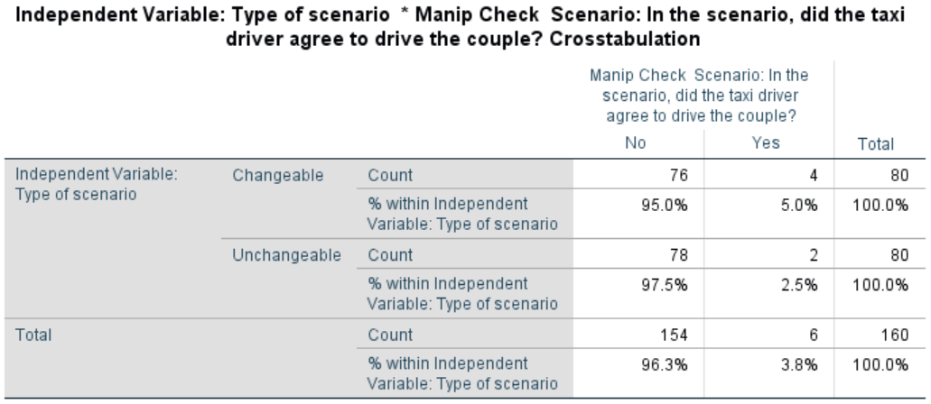
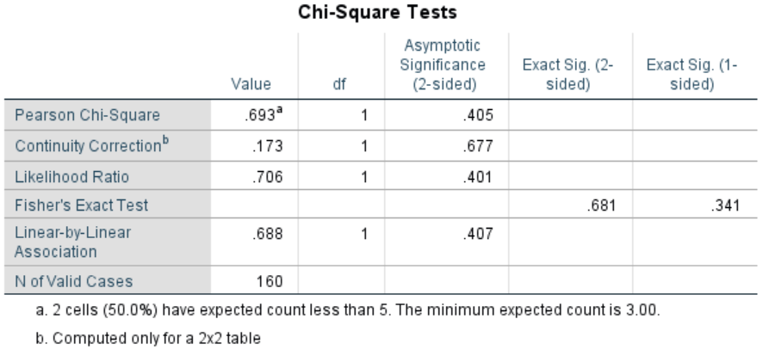
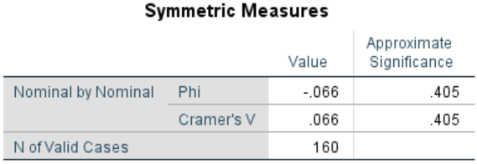
To test our first dependent variable, we ran a 2 X 2 factorial ANOVA with NFC (high vs. low) and scenario condition (changeable vs. unchangeable) as our independent variables and the perceived blameworthiness of the taxi driver as our dependent variable. Results demonstrated no significant main effect for NFC on perceived blame, F(1, 152) = 1.69, p = .196. This means that there was no meaningful differences in the assignment of culpability between the high-NFC (M = 3.72, SD = 2.44) and low-NFC group (M = 4.12, SD = 2.49). There was, however, a significant main effect for scenario condition, F(1, 152) = 3.98, p = .048. Participants in the changeable condition (M = 4.27, SD = 2.35) perceived the taxi driver to be more blameworthy for the couple’s death than participants in the unchangeable condition (M = 3.56, SD = 2.47). Unfortunately, there was no interaction of NFC and scenario, F(1, 152) = 0.00, p = .985, meaning that perceived culpability did not significantly differ among high NFC changeable participants (M = 4.04, SD = 2.28), high NFC unchangeable participants (M = 3.27, SD = 2.44), low NFC changeable participants (M = 4.56, SD = 2.44), and low NFC unchangeable participants (M = 3.77, SD = 2.51). See Table 8
Table 8
ANOVA Perceived Blameworthiness – Study Two
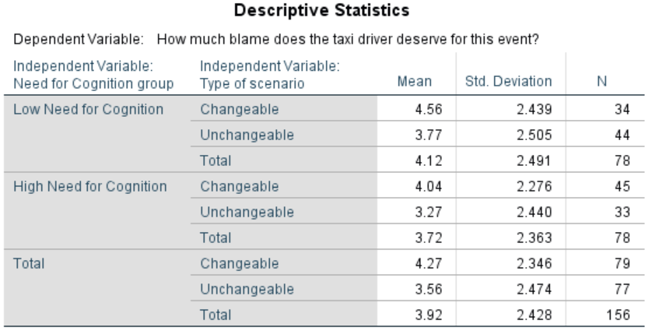
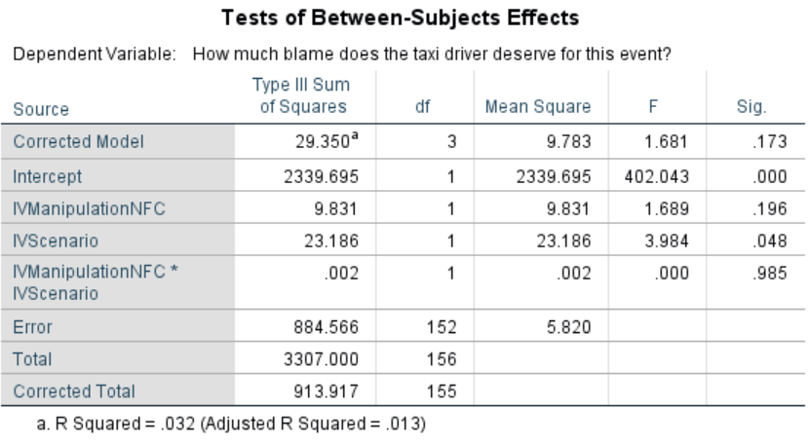
To test our second dependent variable, we ran another 2 X 2 factorial ANOVA with NFC (high vs. low) and scenario condition (changeable vs. unchangeable) as our independent variables and number of “If Only” counterfactual statements as our dependent variable. There was no main effect for NFC on the number of “If Only” thoughts generated, F(1, 156) = .001, p = .975. This means that there was no difference in the number of counterfactual thoughts generated between the high-NFC group (M = 3.87, SD = 1.77) and low-NFC group (M = 3.81, SD = 2.46). Similarly, there was no main effect between for scenario, F(1, 56) = 2.05, p = .154. That is, there was no significant difference in the number of “If Only” statements generated between the changeable condition (M = 4.09, SD = 2.28) and the unchangeable condition (M = 3.60, SD = 1.97). We also examined the overall interaction between the two independent variables (high vs. low-NFC and unchangeable vs. changeable scenario) and the dependent variable. We found that there was no interaction of NFC and scenario condition, F(1, 156) = 1.04, p = .310, meaning that the number of “If Only” thoughts created did not vary between the high NFC unchangeable condition (M = 3.79, SD = 1.92), high NFC changeable condition (M = 3.93, SD = 1.68), low NFC unchangeable condition (M = 3.46, SD = 2.01), or low NFC changeable condition (M = 4.29, SD = 2.93). See Table 9.
Table 9
ANOVA Number of Counterfactuals – Study Two
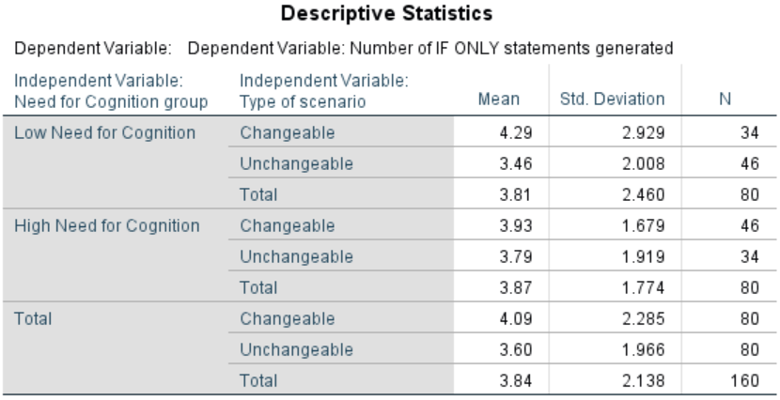
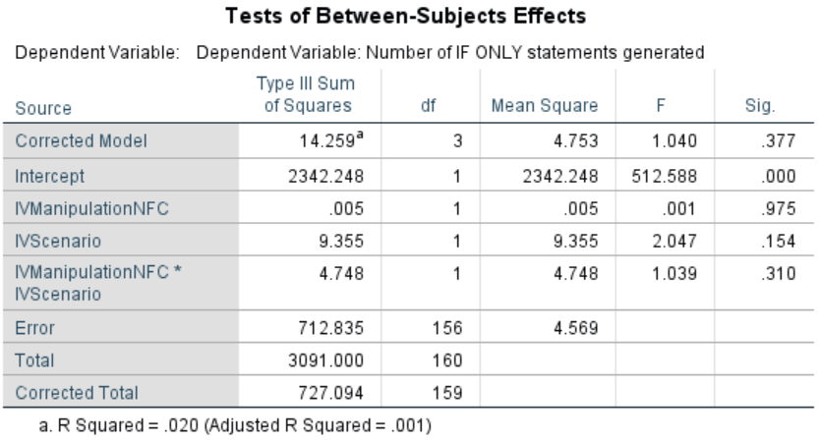
Discussion Study Two
Although study two posited that Need for Cognition would impact participants and their generation of counterfactual statements and their assessment of blame, results did not support this contention. For both dependent variables, Need for Cognition did not result in main effects. Despite predictions to the contrary, those high in NFC did not generate any more counterfactuals than those low in NFC, and those high in NFC did not blame the taxi driver any more than those low in NFC. Nor did NCF interact with scenario, despite our prediction that those high NFC would generate the most counterfactuals and find the most blame when given the changeable scenario compared to other conditions. However, scenario did show a significant main effect such that participants found more blame for the taxi driver in the changeable condition than the unchangeable condition.

